NAME:Rishik JK
REG.NO :192511052

CSA1702-ARTIFICIAL INTELLIGENCE
LAB EXPERIMENT

Experiment 4 – Crypt-Arithmetic Problem

AIM
To write a Python program to solve the Crypt-Arithmetic problem SEND + MORE = MONEY.

ALGORITHM
- Start the program.
- Assign different digits to each letter in SEND, MORE and MONEY.
- Make sure S and M are not zero.
- Convert SEND, MORE and MONEY into numbers.
- Check whether SEND + MORE = MONEY.
- If the condition is true, print the solution.
- Stop the program.

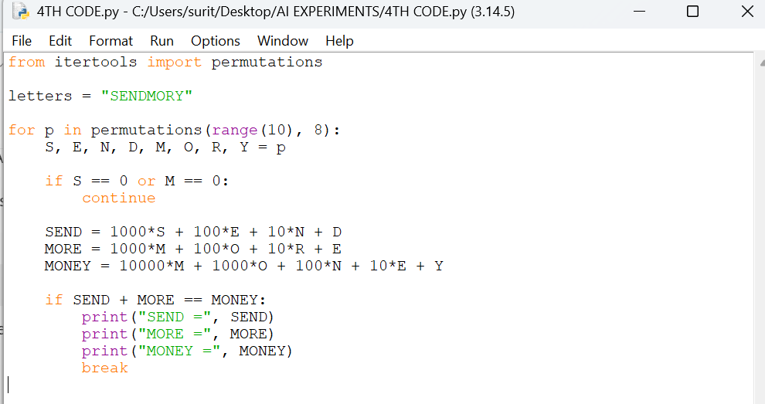

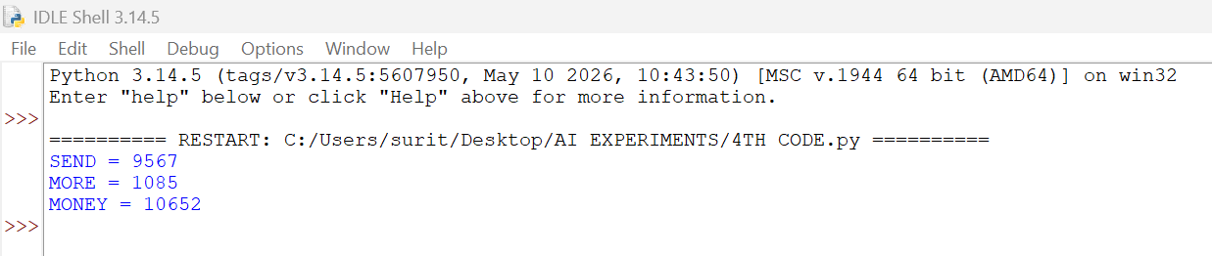

RESULT
Thus, the Crypt-Arithmetic problem was solved successfully using Python.

